High TPS System Design

A High TPS system is a system designed to handle a large number of transactions per second (TPS) reliably, with low latency and high availability, even under peak load.

What is a High TPS System?
TPS (Transactions Per Second) measures how many complete business operations a system can process every second.
A High TPS system typically:
- Handles thousands to millions of transactions per second
- Processes short-lived, atomic operations
- Must be highly available, scalable, and fault tolerant
Examples
- Payment gateways (credit/debit card processing)
- Stock trading platforms
- Ad-tech bidding systems
- Telecom billing systems
- Online gaming backends
- Order placement systems (e-commerce, ride-hailing)

Key Characteristics of High TPS Systems
Characteristic | Why it matters
Low latency | Users and downstream systems expect fast responses
High throughput | System must sustain traffic spikes
Horizontal scalability | Vertical scaling has limits
Fault tolerance | Failures must not stop transactions
Consistency guarantees | Especially critical for money or inventory
Things to Take Care of When Designing a High TPS System
1️⃣ System Architecture
2️⃣ Database Design
3️⃣ Caching Strategy
4️⃣ Concurrency & Thread Management
5️⃣ Messaging & Asynchronous Processing
6️⃣ Data Consistency & Transactions
7️⃣ Scalability & Load Balancing
8️⃣ Observability & Monitoring
9️⃣ Failure Handling & Resilience
🔟 Security & Data Integrity

Typical High TPS Design Checklist
✔ Stateless services
✔ Horizontal scaling
✔ Sharded database
✔ Aggressive caching
✔ Async processing
✔ Idempotent APIs
✔ Backpressure & rate limiting
✔ Comprehensive monitoring

1️⃣ System Architecture
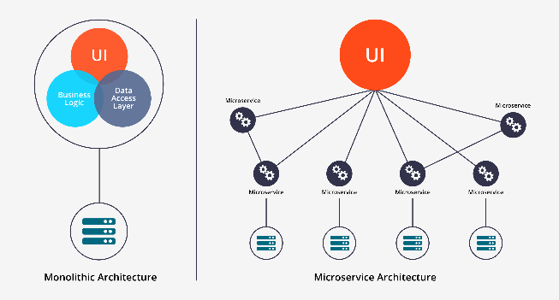 | 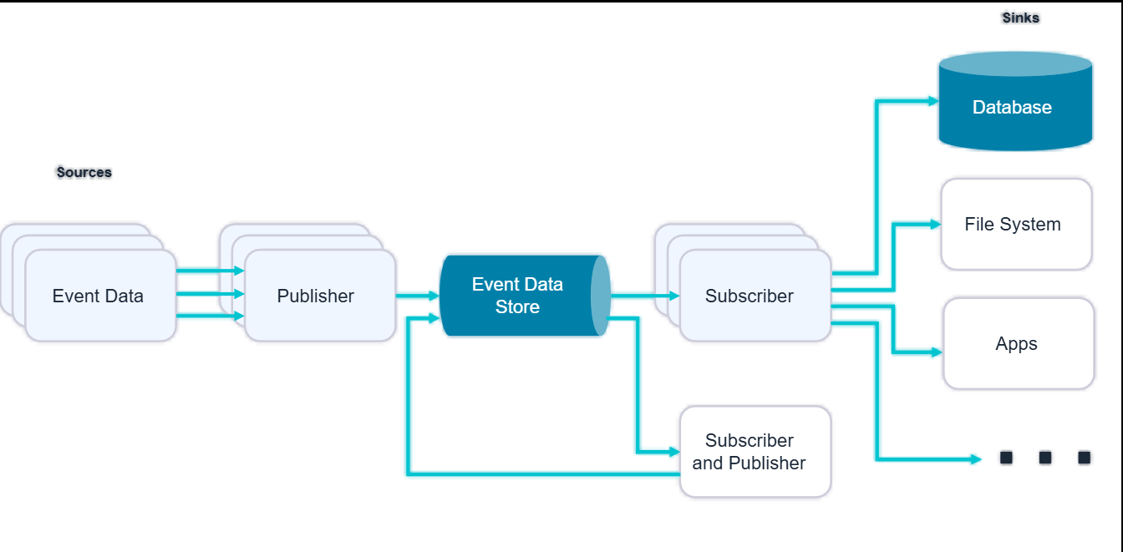

Best practices
- Prefer stateless services
- Use horizontal scaling
- Decouple components using asynchronous messaging
- Avoid tight coupling and synchronous chains
Common choices
- Microservices
- Event-driven architecture
- CQRS (Command Query Responsibility Segregation)

2️⃣ Database Design
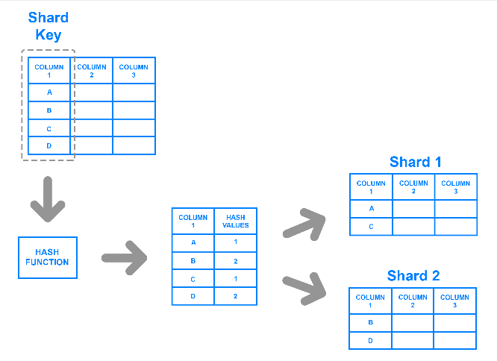 | 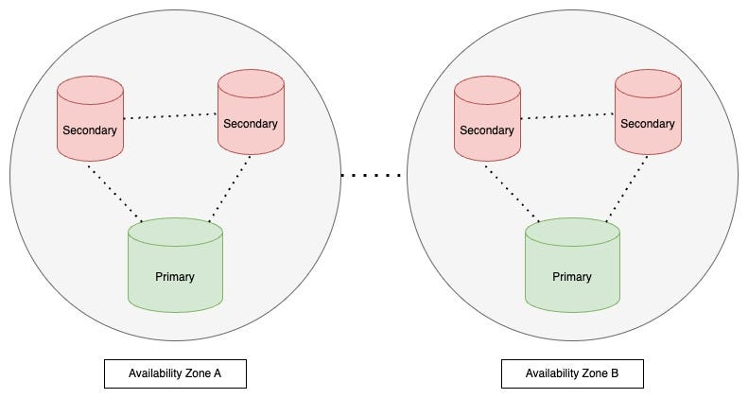

Key considerations
- Sharding / partitioning (by user ID, account ID, region)
- Read-write separation
- Avoid hot partitions
- Minimize joins
- Use batch writes when possible
Technology choices
- Relational DBs (MySQL, PostgreSQL with sharding)
- NoSQL (Cassandra, DynamoDB, ScyllaDB)
- In-memory stores for fast access

3️⃣ Caching Strategy
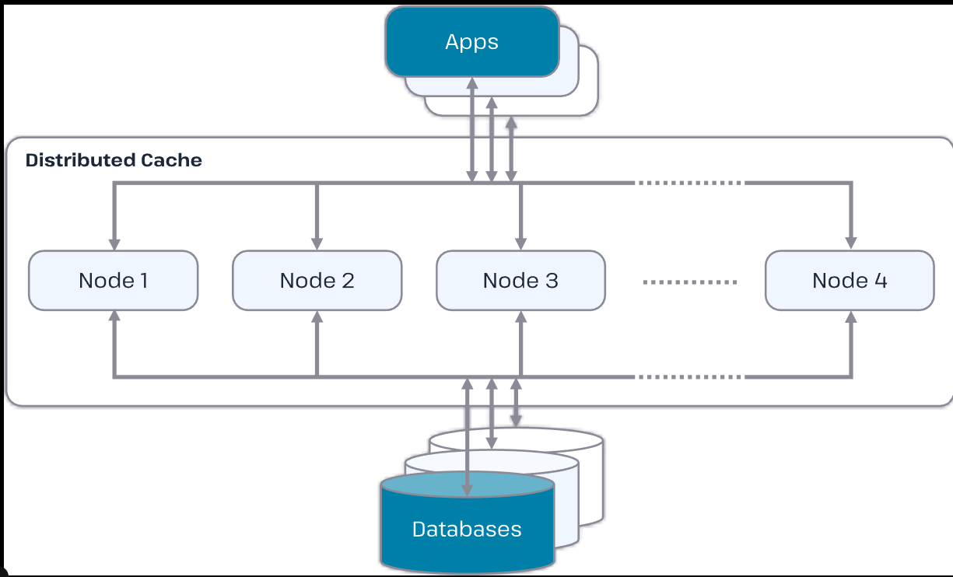 | 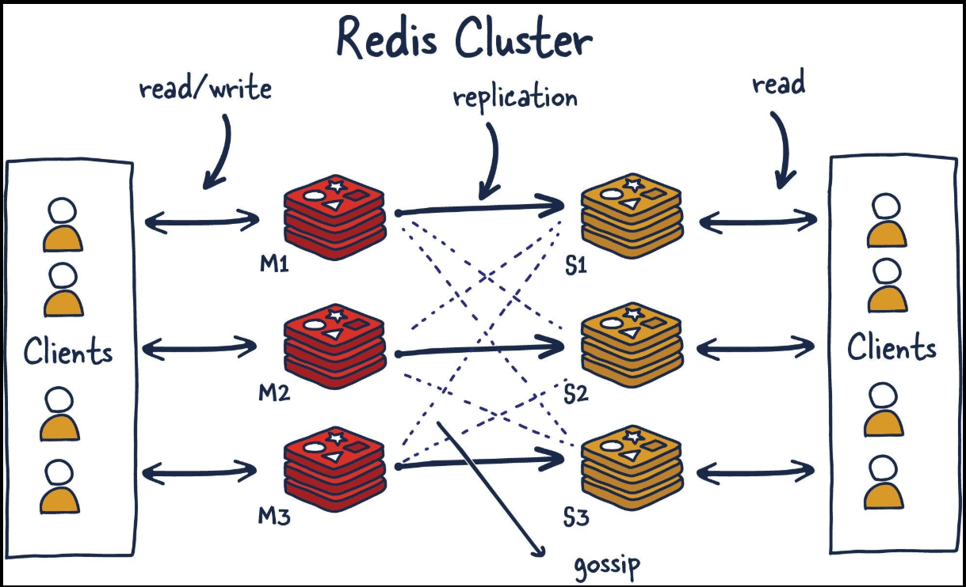

Why caching is critical
- Reduces database load
- Improves latency
- Absorbs traffic spikes
Best practices
- Multi-level caching (L1 in-memory, L2 distributed)
- Use TTL wisely
- Avoid cache stampede (use locks or request coalescing)
- Cache read-heavy data aggressively

4️⃣ Concurrency & Thread Management
Challenges
- Lock contention
- Thread exhaustion
- Context switching overhead
Best practices
- Non-blocking I/O (async, reactive)
- Fine-grained locking or lock-free data structures
- Idempotent operations
- Use connection pooling correctly

5️⃣ Messaging & Asynchronous Processing
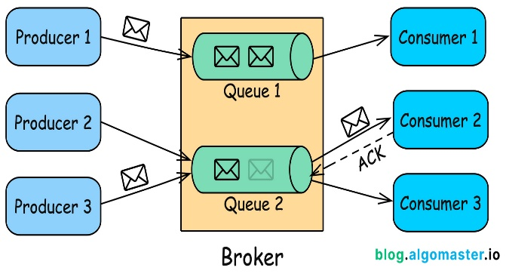 | 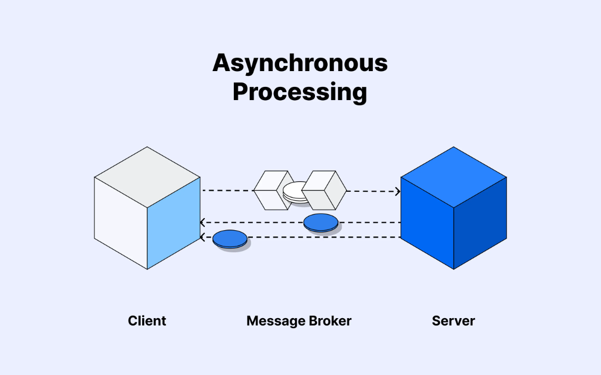

Why async matters
- Smooths traffic spikes
- Improves system resilience
- Enables eventual consistency
Tools
- Kafka
- RabbitMQ
- AWS SQS / SNS
- Pulsar
Design tips
- Ensure at-least-once vs exactly-once semantics
- Handle duplicate messages
- Monitor consumer lag

6️⃣ Data Consistency & Transactions
Trade-offs
- Strong consistency vs availability (CAP theorem)
- Latency vs correctness
Techniques
- Eventual consistency where possible
- Saga pattern for distributed transactions
- Optimistic locking
- Idempotency keys (especially for retries)

7️⃣ Scalability & Load Balancing
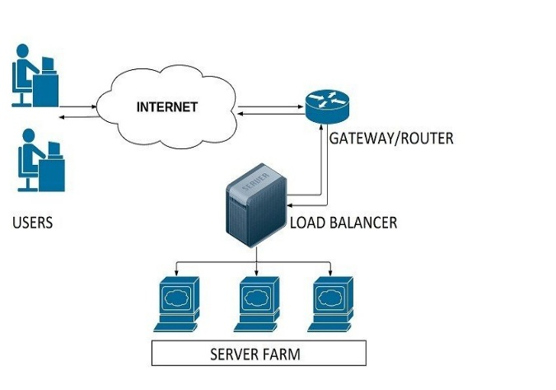 | 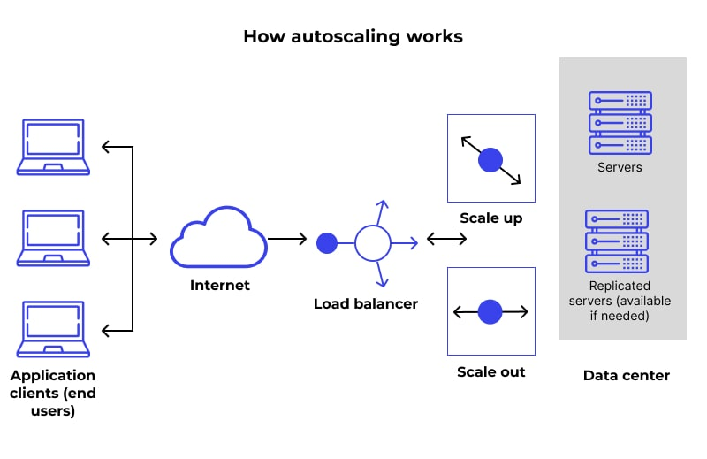

Best practices
- Stateless services behind load balancers
- Auto-scaling based on CPU, memory, or QPS
- Use rate limiting and backpressure
- Graceful degradation under extreme load

8️⃣ Observability & Monitoring
Must-have metrics
- TPS
- P95 / P99 latency
- Error rate
- Queue depth
- CPU, memory, GC pauses
Tools
- Prometheus + Grafana
- ELK stack
- Distributed tracing (OpenTelemetry, Jaeger)

9️⃣ Failure Handling & Resilience
Design for failure
- Circuit breakers
- Timeouts everywhere
- Retries with exponential backoff
- Bulkheads to isolate failures

🔟 Security & Data Integrity
Key points
- Authentication and authorization must be lightweight
- Avoid synchronous calls to external auth systems
- Encrypt sensitive data
- Audit logs must not block transaction paths

Simple Example
Payment processing system
- API Gateway → Stateless Payment Service
- Redis cache for account status
- Kafka for transaction events
- Sharded database for ledger writes
- Async reconciliation
- Idempotency keys for retries

